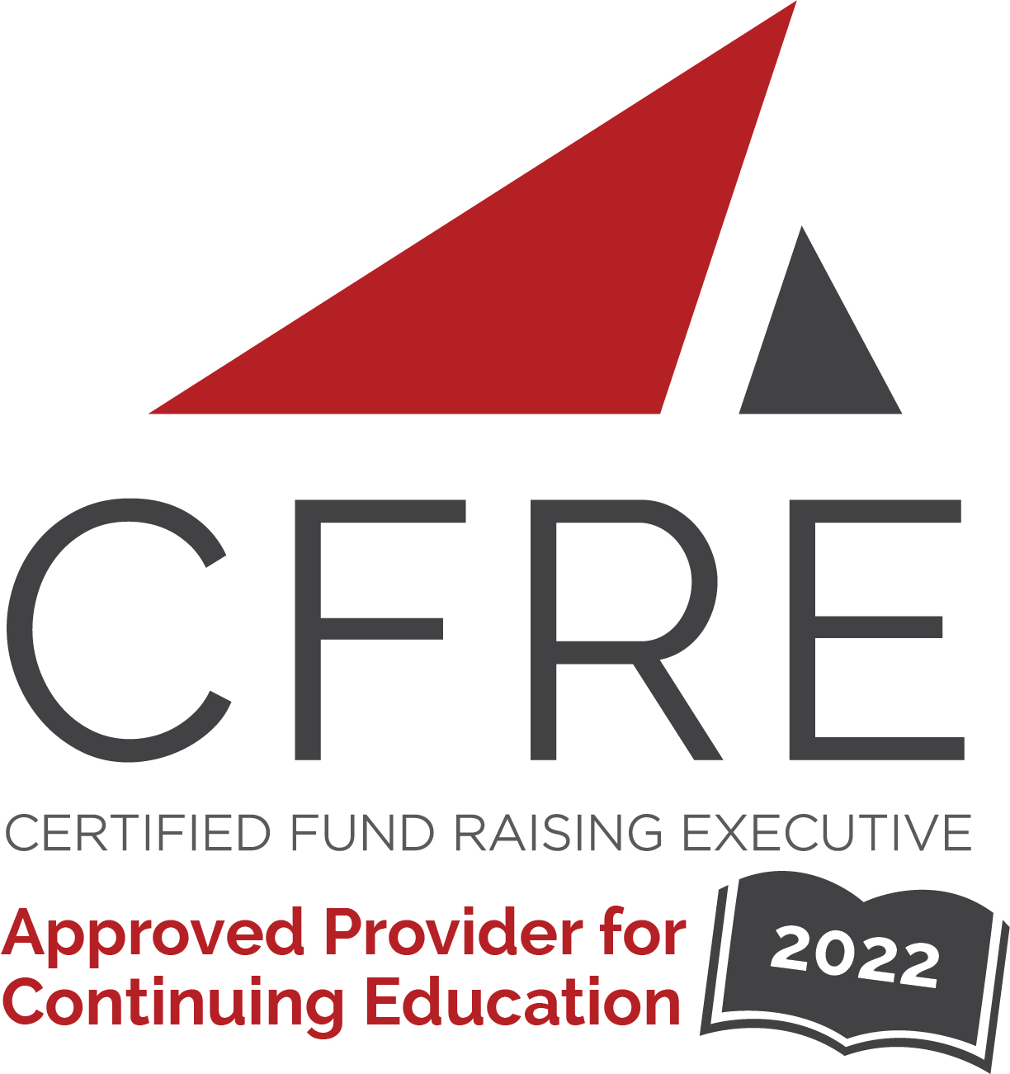  CFRE International has developed this form as a way for you to quickly track (and keep in your files!) the continuing education sessions you have attended. Simply check the boxes next to the sessions you attended. At the end of the conference, add up the total number of hours. Keep this sheet and you will be ready to complete your application form. All of the session slots listed are eligible for continuing education points on your CFRE application for initial certification and/or recertification. Sessions not listed here are not eligible for points. |  | CONTINUING EDUCATION POINTS TRACKER

Activity Organizer: - Foundation Innovation
Title of Activity: - Board2Board Frisco
Names of Presenter(s): - Various
Dates and Location: - November 2, 2022 – Frisco, TX USA

Date: 2 November, 2022
Session 1: 9:45am – 11:00am (1.25 pt)
- Marketing That Matters

Date: 2 November, 2022
Session 2: 11:00am – 12:00pm (1 pt)
- Board Engagement

Date: 2 November, 2022
Session 3: 12:30pm – 2:00pm (1.5 pt)
- How to Become a Fundraising Board
- Juggling the Journey: Time Management

Date: 2 November, 2022
Session 3: 2:00pm – 3:00pm (1 pt)
- Legal and Compliance Update

Total number of points attained: __________

