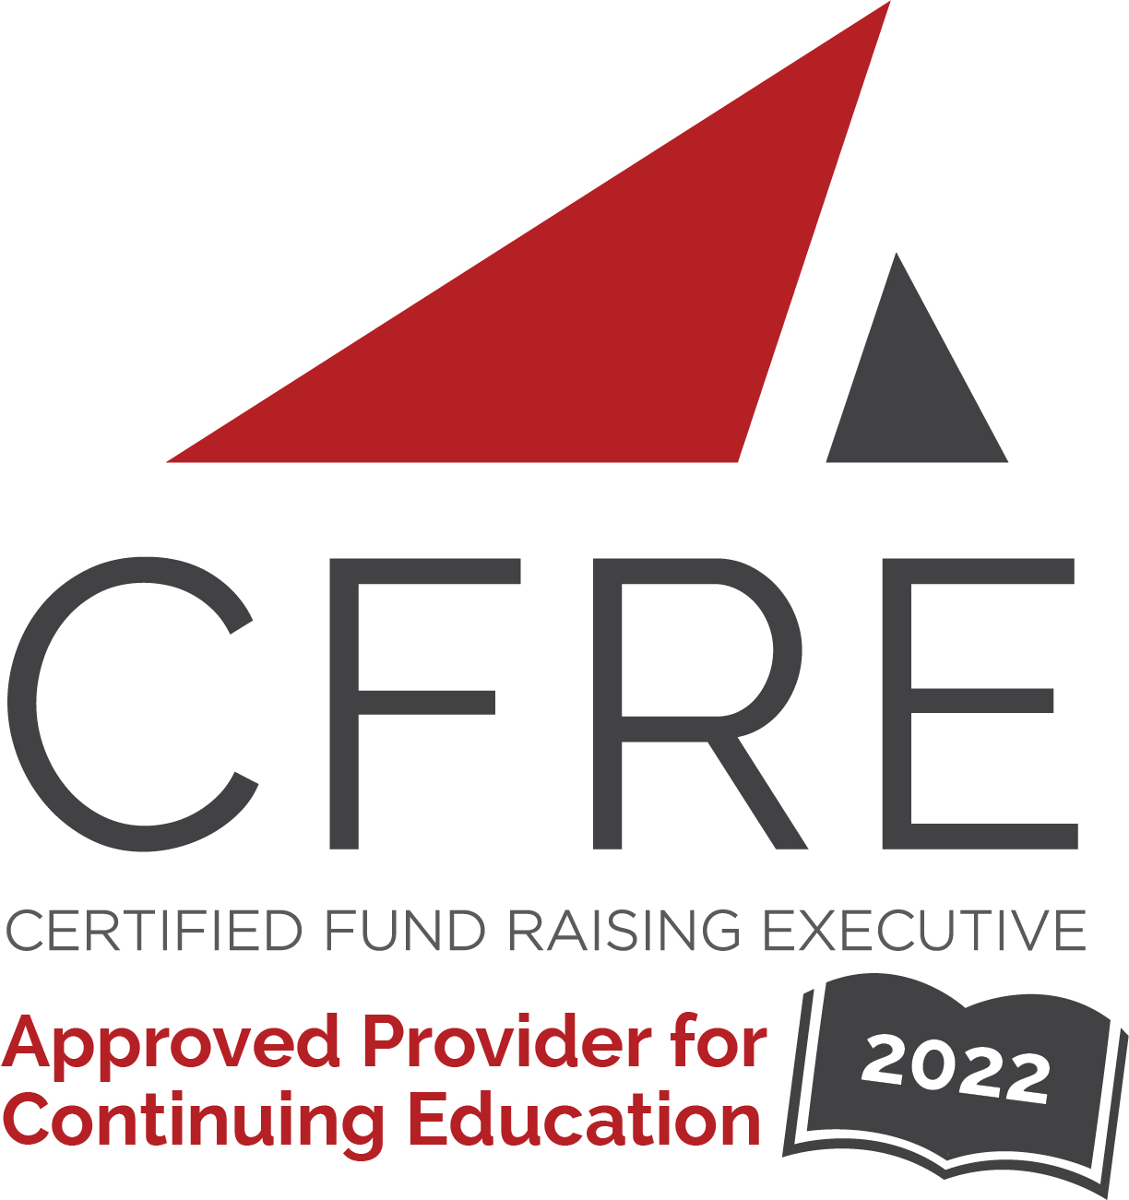  CFRE International has developed this form as a way for you to quickly track (and keep in your files!) the continuing education sessions you have attended. Simply check the boxes next to the sessions you attended. At the end of the conference, add up the total number of hours. Keep this sheet and you will be ready to complete your application form. All of the session slots listed are eligible for continuing education points on your CFRE application for initial certification and/or recertification. Sessions not listed here are not eligible for points. |  | CONTINUING EDUCATION POINTS TRACKER

Activity Organizer: - Texas Education Foundation Network
Title of Activity: - 2022 TEFN Annual Conference
Names of Presenter(s): - Various
Dates and Location: - April 5-6, 2022, San Marcos, TX

Date: Tuesday, April 5, 2022
Session 1: 10:00 [am] – 11:00 [am] (1 pt)
- [Fish Camp - New to School Foundations - Part I]
- [Executive Director Bootcamp - Part I]
- [Onboarding New Board Members is NOT Just an Orientation!]
- [Building a Culture of Philanthropy within Your Foundation]
- [Overview of Governance Issues (New or Re-Emerging Foundations)]
- [Elevating the Relationship between Education Foundations & Districts]

Date: Tuesday, April 5, 2022
Session 2: 11:15 [am] – 12:15 [pm] (1 pt)
- [Fish Camp - New to School Foundations Part II]
- [Executive Director Bootcamp - Part II]
- [Creating Ambassadors - Board Members Who Thrive]
- [Building a Culture of Philanthropy within Your Foundation]
- [Overview of Governance Issues (Established Foundations)]
- [School Mental Health Programs] NFR

Date: Tuesday, April 5, 2022
Keynote: 12:30 [pm] – 1:15 [pm] (1 pt)
- [Mentorship VS Management]
Date: Tuesday, April 5, 2022
Session 3: 2:30 [pm] – 3:30 [pm] (1 pt)
- [Building Engaged, Involved and Active Boards & Committee Members]
- [The Art of Making the Ask]
- [Transitioning from Event-Centered Fundraising to an Annual Campaign]
- [Managing What Matters Most – Time & Fundraising Strategy]
- ["Hey Guys!" Effective Branding through Social Media]
- [How to Develop a Fundraising Board]

Date: Wednesday, April 6, 2022
Session 1: 8:45 [am] – 9:45 [am] (1 pt)
- [How to Align Funding Priorities of an Education Foundation
with the School System]
- [Basic Financial Literacy and Understanding the Financial Health
of Your Foundation]
- [Please Take Our Money! Addressing the Current Trend in Funding
Campus Grants]
- [Donor Development & Stewardship]
- [The Evolution of a Transformation]

Date: Wednesday, April 6, 2022
Session 2: 10:00 [am] – 11:00 [am] (1 pt)
- [What I Wish I Knew Then]
- [Marketing & Communications for Your Nonprofit]
- [Effective & Efficient Back Office Practices for Your Foundation]
- [Grow Your Own: Empowering Board Leadership]
- [LinkedIn: Why & How to Use for Your Foundation]

Date: Wednesday, April 6, 2022
Keynote: 11:15 [am] – 12:15 [pm] (1 pt)
- [Bringing It All Together- Lourie Cromwell]

Total number of points attained: __________

